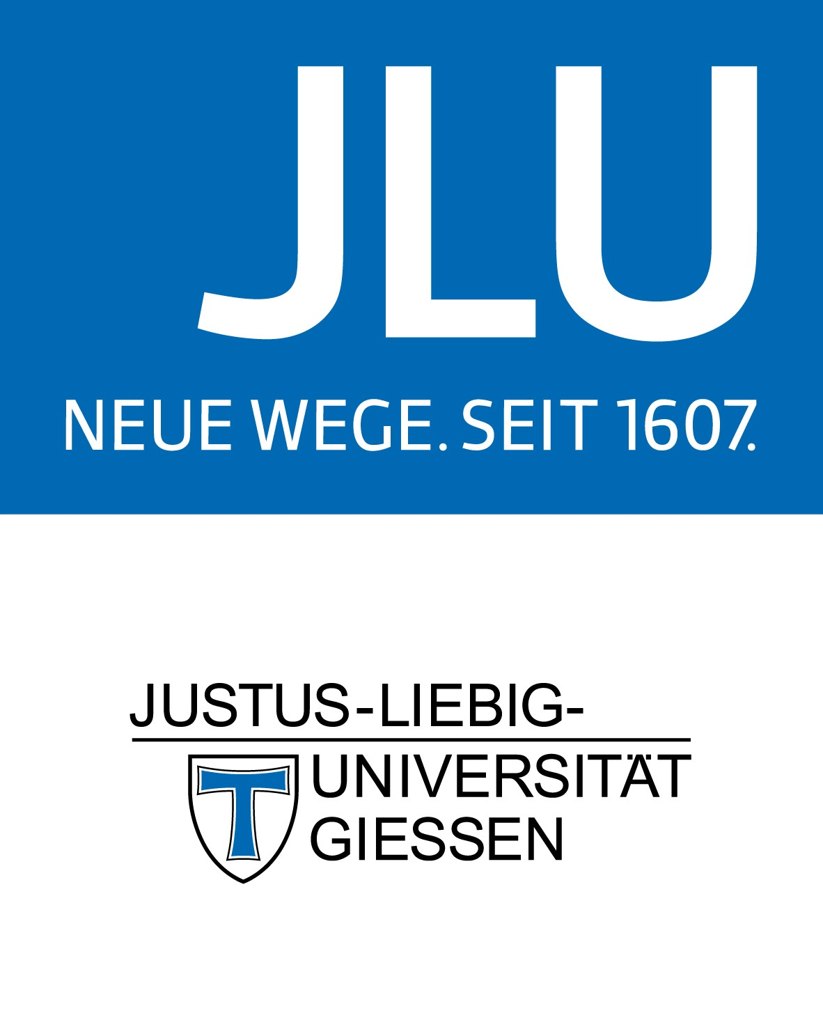

**Topic for a thesis Master of Science**

**Supply of soils with organic matter and soil carbon dynamics in the “Organic Arable Farming Experiment Gladbacherhof” (OAFEG)**

The supply of soils with organic matter is a basic concern in sustainable arable farming systems. The amount and turnover of organic matter impacts on all relevant soil functions and, thus, is recognised a key factor of soil fertility.

Further, the sequestration of carbon in soils contributes to the mitigation of climate change.

The Organic Arable Farming Experiment Gladbacherhof has been started in 1998 to compare different organic crop-rotation/fertilization and tillage treatments. Today, the experiment is one of the oldest long-term field experiments in organic farming that is still continued. Therefore, the experiment provides an extraordinary data base for the assessment of the impact of organic management on soils, plants and the environment.

The proposed study will analyse the development of organic matter supply and soil organic matter stocks dependent on the treatments in the first 4 rotational cycles (24 y!) of the long-term field experiment. This includes the assessment of the temporal course of C and N stocks in soils as well as the application of a model on soil organic matter dynamics that has been developed at the JLU Chair of Organic Farming.

The study will be conducted and supervised as a collaborative project of Giessen University and Forschungsring e.V.

If you are interested or have further questions, please contact one of the following persons:

Dr. Wiebke Niether [wiebke.niether@agrar.uni-giessen.de](mailto:wiebke.niether@agrar.uni-giessen.de)

Prof. Dr. Andreas Gattinger [Andreas.Gattinger@agrar.uni-giessen.de](mailto:Andreas.Gattinger@agrar.uni-giessen.de)

Dr. Christpoher Brock [brock@forschungsring.de](mailto:brock@forschungsring.de)